Rome: Invicta

In the beginning of the civilized world, Rome was a powerhouse of its own world. Now, you can find out if you have what it takes to run Rome as prosperously as the Senators.

Rome Invicta is a semi-cooperative worker placement game in which you take on the role of a ruling duo, a Senator and their ally. Players take turns placing their citizens and their leader across Rome to increase their own power or standing, or to make sure to keep Rome as powerful as it is, as war looms on the horizon as Rome has many enemies. As time progresses, will you pass laws that benefit Rome as a whole, or will you slip into the tempting nature of corruption?

Setup

Place the board in the center of the playing surface. Shuffle the Law, Action, Improvement, and Building decks into separate piles and set them aside. Shuffle the level 2 campaigns in one pile, then shuffle the level 1 Campaigns separately in another pile. Place the level 1 campaigns on top of the level 2. Place the Gold, Corruption, Time and Resource tokens near the board. Each player chooses their color, then randomly gets 1 Ally and 1 Leader to play as. They then collect their starting Gold and Resource tokens from the common supply, then gain their starting citizens, army cubes, and influence cubes, along with their Leader, and places them on their personal boards. Flip the first 3 Improvements and Buildings from the deck and place them below the University and Town Hall respectively. Place 1 cube from your supply onto the point board on 0. Have each player give someone a cube of their color, then that player randomly picks one. This is the Emperor, or starting player. Place a number of tokens in Wealth and Storage equal to ½ the number of players, rounded up, plus one. Then place a number of tokens in peace equal to ½ the number of players, minus one. You are now ready to play.

**The Board:**

**Forum – No cost => Draw a law card.**

**University – Pay the cost of one available Improvement => Gain that improvement. OR 7+ Gain an Improvement -1 cost.**

**Improvements – 3 Improvements are available after each players round.**

**Barracks – Pay 1 influence => 1 Army (same for 5+) OR pay 2 influence for 2 army (same for 7+)**

**Campaign – Put any amount of army cubes on the Campaign.**

**Stage – Rome gains 1 Wealth or Stores => Gain 1 influence**

**Church – Pay 2 gold – Gain 2 victory points OR Pay 2 gold for an influence and Rome gains 1 peace OR pay 2 gold, choose either of the previous effects.**

**Colosseum – No Cost => Draw 1 action card, then draw 1 card for each other player at the Colosseum**

**Empty Plots – 6 Empty areas for buildings to be built**

**Rome – Rome’s Peace, Wealth and Storage are tracked here.**

**Town Hall - Pay the cost of one available Building => Gain that Building. OR 7+ Gain an Building at -1 cost.**

**Buildings – 3 Buildings are available after each players round.**

**Market – Rome gains 1 Storage => gain 1 Resource OR Rome loses 1 Storage => gain 2 Resources and 1 Corruption OR 5+ no cost => Gain 1 resource OR 7+ Each other player gains a resource => gain 2 resources.**

**Road – Pay 1 Resource => gain 2 Gold OR Rome loses 1 Wealth => gain 2 Resources and 1 Corruption OR 5+ no cost => Gain 1 gold OR 7+ Each other player gains a gold => gain 2 gold.**

**Aid – Choose 1: Pay 1 Gold => Rome gains 1 Wealth, you lose 1 corruption; Or Pay 1 Resource => Rome gains 1 Stores, you lose 1 corruption; Or Pay 1 Army => Rome gains 1 Peace, you lose 1 corruption**

**The Cards:**

**Campaign – The army requirement is a**

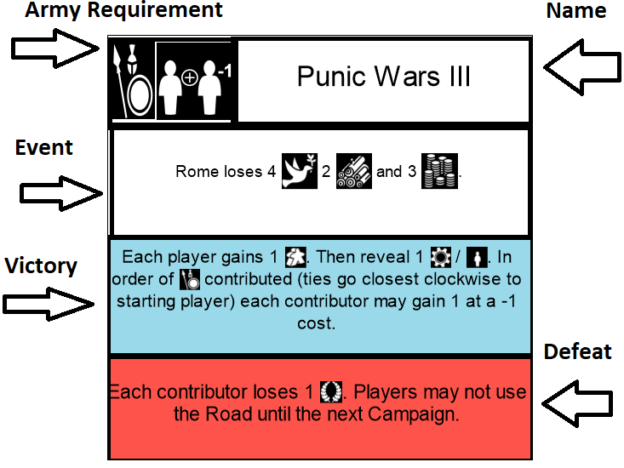

**Law**

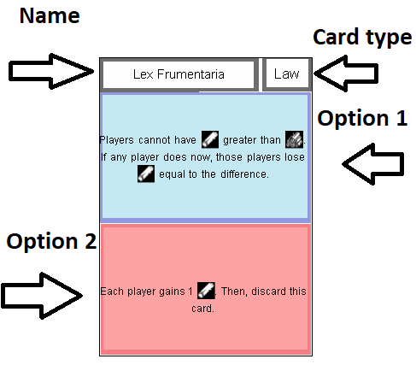

**Action**

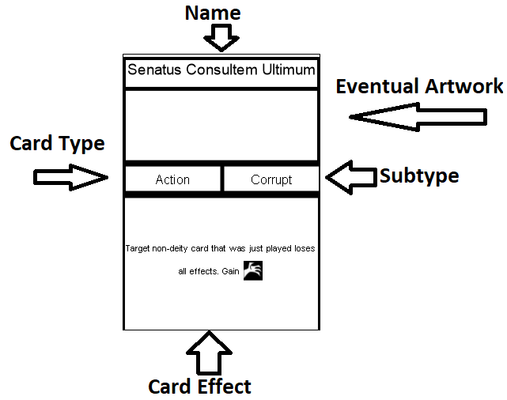

**Leader**

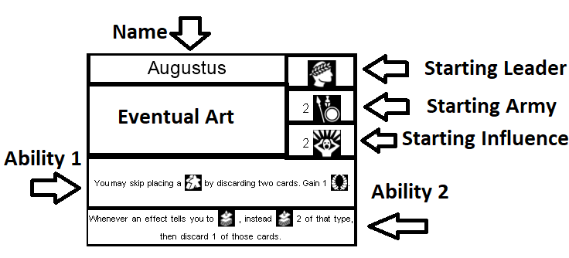

**Ally**

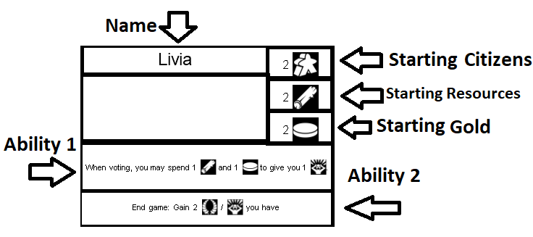

**Building**

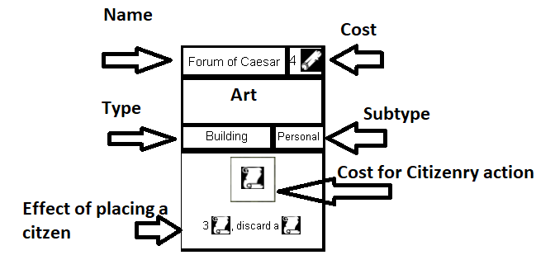

**Improvement**

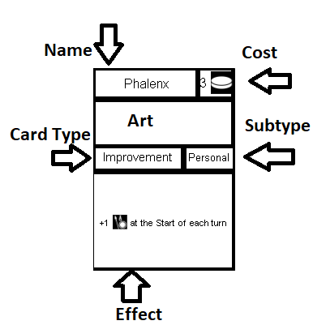

**Turn Structure** –

**Citizenry Phase** - Play begins with the starting player. Players play out rounds one at a time, choosing to place either one of their citizens or their leader or by choosing to pass. If a player places a citizen or leader, they pay the cost inside the space, then gain the benefits outside the space. This happens immediately. Some spaces will only allow your leader into them. They are marked with the leader symbol. Once a player has passed, they cannot take any more actions during the Citizenry Phase. Players take turns placing citizens until all players have chosen to pass.

**Campaign Phase** – Once all players have passed, the current Emperor (first player) places a Time counter on the Campaign deck. Then, if the number of Time Counters is less than this number, skip to the voting phase. Otherwise, if the number of Time counters is greater than or equals the number on the Campaign deck, flip and resolve the effect of the Campaign. Compare the number of army cubes on the campaign card to what the requirement of the campaign is in the top left corner. If the number of cubes is greater than the requirement, resolve the victory effect. Otherwise, resolve the defeat effect. Then proceed to voting.

* Some effects may cause you to “flip this card.” If they do, place the Campaign tile directly next to Rome on either the left or right side of the board. This is new territory, and new buildings may be built here.

**Voting Phase** – Each player, starting with the current Emperor, may add a card facedown to the current Agenda, or cards to be voted on. The Emperor shuffles the pile, then each player takes their corresponding role card, based on where they are in the turn order.

Principis Senetus – This player cannot vote. Also breaks ties. They start each vote by choosing a vote from among the Agenda pile and placing it on the table and reading it aloud.

Consul – This player gets to vote first.

Ex-consul (6+) – Once per voting phase, choose to enact this ability. The first player to place influence on the opposite choice of yours loses 1 Victory point.

Praetor (5+) Before each vote*, this player may spend 1 army to gain 1 influence cube for this vote.

Pontifax maxima – Before each vote*, this player gains 1 Influence for this vote if you used the Church this turn.

Ex-Praetor (8)- Before each vote*, this player may pay 1 gold for 1 influence cube.

Censor (7+) Once per voting phase, before a vote*, choose a player. That player cannot vote on this law.

Veto - Once per voting phase, before a vote, you may discard that law.

*Before a vote abilities happen after the vote has been placed, but before the Consul places their influence.

How to vote – The Principis Senetus places the vote and reads it aloud. Then, voting begins with the Consul. During your action in the voting phase, move any amount of influence cubes to the vote option of your choice. Then, you may place any number of unused citizens there to advocate for your vote. Each citizen adds +2 to that vote. Then the next player in turn order does the same. This repeats until the Veto player has gone. The vote then resolves for whatever option has more votes. The Principis Senetus then places a new law out of their choice to vote for from the Agenda pile. This series of actions continues until no Laws are left to vote on.

*If a vote is placed out, but no player can or chooses to place influence or citizens on either option, the Principis Senetus chooses which option passes.

**Clean-up Phase** – Players then return all influence cubes on laws to their personal supply (not to their boards) then returns all citizens to their boards. Check to see if Peace, Wealth or Stores are at 0. If one or more is, each player in the lead loses 1 point. If 2 are at 0, each player with more than 1 Gold loses 1, then do the same for Resources. If all three are at 0, the game ends. The Emperor passes their power to the next player in the line of Succession (turn order). This act marks the end of the turn (end of turn effects happen now) Then, the new Emperor starts the next turn.

**Ending the Game –** The end of the game can start in 1 of three ways. 1 – If a time counter needs to be placed, but there are none remaining in the Campaign Deck, this triggers the end of the game. Skip the voting phase. Each player calculates their final scores as follows.

-Current Score

-End of game bonuses

- 1 Victory Point for every 3 Gold

--1 / 3 Corruption you have.

The player with the highest total wins! 2 – If, at the end of the turn, Rome’s Peace, Wealth, and Stores are all empty, each player loses the game. Rome has burned to the ground do to petty infighting between its senators, and Rome is forgotten in history. 3 – Pax Romana. If a player plays this action card, and its conditions are met, each player wins the game. Rome prospers and is remembered as one of the great civilizations of history.

FAQ:

General:

Golden Rule- If a card effect would contradict the base rules, follow the card effect.

If an effect gains you a citizen, you gain it from your personal supply. If you have no citizens to gain, skip this effect.

Mancipatio – If Blue, Players now have the option to trade Gold Army and Resources with other players. They must trade an even 1 for 1, and both players must agree to the trade. If red, each player may trade in any number of Resources or Gold immediately and gain 1 Victory Point for each of those traded this way.

Laws:

Lex Cenilus – If blue passes, Leaders may go on a space occupied by a citizen. They may not go on a space occupied by any leader. If red passes, instead of placing Leaders on any square, they man only use those spaces that only allow Leaders.

Lex Frumentaria – If blue passes. Players cannot gain resources if doing so would cause them to have more resources then Rome has Stores. If, when the law passes, a player does, they lose Resources above whatever Wealth Rome currently has.

Lex Sumptuaria – If blue passes, if any effect or cost would cause a player to spend 2 or more gold (like gaining an improvement), that play must also discard a card, or they lose 1 victory point.

Debt for Power – If blue passes, during the Citizenry phase*, each round you may use this effect.

Emperor – Blue: Starting with the current emperor (or the player closest to them in turn order) each player has one vote to select a player. Whoever has the most votes gains the victory points. In the case of a tie, the Principus Senetus chooses a player among the tied players. Red: : Starting with the current emperor (or the player closest to them in turn order) each player has one vote to select a player. Whoever has the most votes loses the victory points. In the case of a tie, the Principus Senetus chooses a player among the tied players. *Then discard this law

Limited Ballot – Blue: Instead of selecting and voting on multiple laws, the Principus Senetus randomly chooses 1 law each round for everyone to vote on, then discards all other laws.

Law of Torts – Blue: If a player targets another player with an effect, the targeted player may take their choice of one Resource or Gold from the player that targeted them. Red: You can only target a player if they have more Corruption than you.

Lex Tullia – Blue: During a vote, players may use Corruption as Influence. Red: Each player loses 3 Corruption. If you cannot lose 3, you gain 1 Victory Point for each Corruption you could not lose. (If you had 1 Corruption, you would gain 2 Victory Points)

Lex Valeria Horatia – Blue: Immediately after a vote passes, each player, in turn order, has the opportunity to put 2 citizens from their board onto this law. If they do, discard the law that was just passed. Red: Players can no longer advocate for additional influence on laws.

Follow the Leader – Blue: During the Citizenry phase, when the first player of the turn decides to pass, each other player must then decide if they too will pass (this takes place before those players take a turn) Any player that does not loses 5 Victory Points. Then play continues. Red: Each time a player chooses to pass, any other player may also choose to pass. Any player that does gains 1 Victory Point (This effect occurs even if it is not the first player to pass.)

Capitas Deminatio – Red: During each turn, the first player to remove their last citizen from their board, loses 3 Victory Points.

Cess Obnorum – Before the Citizenry Phase each turn, in turn orders, players may pay either 2 gold or 2 resources to remove 1 Corruption from themselves.

Balance of Power – For the Voting phase, players take the position cards based on their point totals, not by turn order. The player in first takes Princeps Senetus, the player in second becomes the Consul, etc. In the case of a tie, see who has the greater amount of influence. If players are still tied, it is whoever has the greater amount of army cubes. If there is still a tie, determine randomly.

Lex Appelcia Agoria – Blue: Any player may place their citizens on a space that already has other players citizens on it, but only if they have less corruption than each player occupying that space. Red: A player may place a citizen onto an occupied space but doing so returns the original players citizen to its owner’s board.

Black listed – Blue*: In turn order, select a building that may not be used in the upcoming turn. Then return all time tokens on buildings before each voting phase. Red*: In the upcoming turn, each player can place two of their citizens each round.

Lex Atilia Marcia – Blue: Instead of paying the cost inside the barracks spaces, a player instead acts as if the cost was 0. Red: Players cannot gain Army if they would gain more Army than Rome’s Peace. Players are not penalized for having more at the time the vote passes, but cannot gain more until they either raise Peace higher or reduce their own Army below the current peace. Players that gain more than 1 army at a time that would cause them to go beyond the current peace only gain army until they equal peace. They do not gain the other army. They do not get any of the cost back.

To the Victor – Blue: If an effect grants a benefit only to those who participated, instead grant that benefit to each player. Red: Level 1 campaigns trigger each round. Level 2 trigger 1 round earlier. (This will speed up the game)

Omenspeaker – Blue: The Princeps Senetus may discuss any aspect of the Campaign card. They may tell the truth or lie. Red: After revealing a Campaign card, its effect happens, then happens again.

Grand Victory – Blue: This effect replaces the normal Colosseum effect. Red: If any player is on the Colosseum, no other player may place their citizens or leaders there. A player who has a citizen or leader there may place additional ones.

For Rome – This happens in turn order. Each player chooses to place a citizen in order, then after all players have placed them, each player chooses what to increase in turn order. Red: This happens once each turn, even if more than 1 of the 3 are below 5.

Hard Work incentive – Red*: This effect only triggers when the first player places their last citizen from their board.

Fluctuating* Population – Blue: This affects certain cards, as well as campaigns. Campaigns will be more difficult. In a 4 or 6 player game, this does not allow players to use the 5+ or 7+ spaces respectively. Red: This will cause Campaigns to be easier, as you are acting as if there is one fewer player.

Lex Calpersia – Blue: If you have Corruption, you lose a citizen from your available citizens (First, choose one from the board if available. If you have no workers available, choose one from the building randomly) (you may place the worker onto this card to remind yourself) If this law is discarded or you remove all of your Corruption, you regain the worker immediately.

Shared Knowledge – Both: Neither of these affect start of game bonuses. Blue: This effect lasts for as long as this law is in play. (Including End of Game Bonuses) Red: This This effect lasts for as long as this law is in play.

Democratic Republic – Red: Each citizen adds +4 Influence to a Law vote.

Expansionism – Blue: This ability only counts for buildings build on the back side of Campaigns that add extra space to build. They do not count for the space in Rome for built buildings. Red: This limits building on the backside of Campaign cards until 2 campaigns have finished. (You can use time counters on this card to remind you)

Demilitarization* - Blue: Campaigns require more army now. In a 4 player game they require 2 more cubes. Round up. Red: for example if the campaign requires 6 army cubes, but there are only 3, and Rome has 5 peace, you would reduce peace to 0, then follow the victory effect. This is not optional if the campaign would fail.

Lex Aciliu Repetundurum – Blue: If a player has 1 or more corruption, they cannot vote in future votes. If all players have Corruption, the Princeps Senetus chooses the outcome.

Lex Cassia Tabellaria – *Blue: This also includes putting citizens in your hand as well. Players choose which hand secretly, then reveal as a whole. Any before voting or Senate powers trigger before the reveal. Red: Normally, players may not divide their vote, but now can place influence on both sides if they desire.

Campaigns: General: Contributors refer to any player with 1 or more army cube. Defeat conditions are in effect until the next successful Campaign. Flipping a campaign allows more buildings to be built in the spaces awarded.

Gallic Wars: Defeat: Each player may only vote on 1 law during the entire voting phase (as they only have one influence) As always, in the case of a tie or no votes, the Princeps Senetus chooses.

Civil War – Victory: *May draw a law

Macedonian War – Victory *May draw a law. Each player chooses if they would like to draw a law. If a player does not, they must gain 1 gold if able. Defeat: *or Stores, or Church spaces. This limits players until the next campaign (Victorious or not) to only placing citizens on spaces that increase Stores Wealth or Peace, or the church spaces.

Punic Wars – Victory: In the case of a tie for highest contributor (most cubes) the reward is chosen randomly. *2 wealth or 2 Stores. Defeat: This removes all the available to build or obtain buildings and improvements, not ones already built or obtained. Until the next campaign, no players will be able to gain buildings or improvements.

Phyrric Wars – Victory: If a player has 0 army at this time, they do not gain any points. The contributors gain the army after the first effect. *Rome loses 1 Storage and each player loses 1 Resource.

Latin Wars- Defeat:*and stores to 1. The last effect lasts until the next campaign and only affects that campaign.

Cynoscephalae – Victory: *Draws a card Defeat: *peace, Stores or wealth.

Punic Wars II Victory: *Draws a card. Defeat:*1 wealth or 1 Stores.

Battle of Actium – Victory* 1 gold or 1 resource. Increases wealth, stores, or peace* Defeat: Flipping a victorious campaign is considered gaining additional land. So if an effect would cause you to flip the next campaign, instead ignore that.

Teutonburg Forest – Victory: *resource and 1 gold. 2 Stores and 2 wealth. Defeat: place the worker on this card as a reminder. Decrease wealth and *Stores by 1. If either is at 0, each player loses 3 victory points.

Action Cards: Despite their name, these do not take up your action for the turn. If a card requires you to reduce Rome’s peace stores or wealth, or for you to spend anything, you must have at least the amount requested to do the action.

Senatus Consultem Ultimum – This can affect any other action card that is not a deity. Discard the card without effect. Then, gain a corruption.

Roman Aid – Instead of paying the cost of a building or improvement with gold or resources, you may use Rome’s wealth instead of gold, or Rome’s Stores instead of Resources. You then gain 1 corruption for each wealth and or stores you use. (If an effect allows you to spend gold as resources or vice versa, you may spend wealth as storage or vice versa as well.)

Demolition* - You may remove a built or researched building or technology in play, or one that is available to be built or researched. You may not search the deck for a specific card.

Tactical Retreat – This card can be played at any time, including after the campaign has been flipped but before it resolves. The cubes return to your board* not your personal supply.

Tight Quarters – You may use a spot that already contains any other citizen or leader with one of your citizens.

Patronage, not bribery – this affects all the cubes of 1 specific player. Their influence is moved from one option to the other. This does not affect citizens advocating for a player.

Veto – This can affect a law that just passed or one that is already in play.

Taxes – When Rome gains the gold, it becomes Wealth. In the case of an ability affecting the number of players, increasing you may take the extra from the general supply, or decreasing the player in last place does not pay. If more than one player is tied, each player pays, then put the extra coin into Wealth.

Succession Crisis – This affects both turn order and for the senate. *After the turn, it goes back to where it left off.

Ides of March – This only affects citizens that player currently has possession of, not from their personal supply. If a player had a citizen on a building, players can now use that building. They return to the players board at the end of the turn.

Open to the public – You gain the gold from the general supply.

War Effort – You can use this card after the Time counter has been placed for the turn. If you do, the campaign does not happen yet if that would have caused it to flip.

Praetorian Guard – This is checked before the card played resolves, in case that would add or remove corruption.

Damnatio Memoriae – The player gains the two cards, then continues the game normally. The player does not gain anything from the new card, but does now have access to their abilities. You can target yourself with this.

Ambitus – you must reveal all cards in your hand, including any laws you may have but have not played yet.

Reinforcements - *From your board.

Legal Reform – This discards all current laws in play. Any effects that were affecting gameplay end immediately.

Freeing Spartacus – The removed citizen must be in play, either on the board or from your player board. The gold or resource tokens come from the general supply. This card cannot be targeted by player or card effects once it has the citizen on it. For all purposes of card effects, the citizen is no longer in the game.

Respect the Elderly – If a player has passed for the turn and you return their citizen, they still cannot take any more citizen actions. They may use the citizen for voting.

For the greater good – Twice the benefit means whatever the outside of the space is now doubled. This effect only counts for the next citizen you place and ends at the end of the turn.

Renaissance – This only affects those buildings and improvements available for purchase.

Acta Senatus – This happens immediately even if it is not the Voting phase. Influence and citizens spent stay there until the next clean up step. If the law effects the action or effect that was about to take place, it affects it as if it were in play prior to the action or effect.

Pax Romana – If this card is played and the conditions are met, everyone wins. Hurray! No tie breakers or funny business. You have made Rome great again.

Deity cards – You choose the option when played. Most have an option that benefits you, one that benefits Rome and everyone, and one that gives you bonus points.

Venus – you do not pay the costs if you choose option 1.

Neptune - *Stores not resources

Minerva – Option 3 Counts action cards and laws

Mercury – Option 2 only you gain the victory points

Vesta – Option 2: those citizens go to your player board. Option 3 is per citizen you have available

Pluto – Option 1: The citizens must still be placed legally. The owner gains the benefit and pays any costs. They must have the cost in order to be placed as normal. Option 3 you are immune from all effects that target a player. If an effect would affect all players or multiple players, you are still affected as normal.

Characters:

Nero – 1st ability: *May pay 1 VP if they do not… 2nd ability: Rome collapses if Peace Wealth and Stores are 0 or lower.

Commodus – 1st ability: The player may pay the influence without you drawing a card or them increasing peace, if either of you don’t want too. 2nd ability: No matter what effect causes it, if you place 1 or more army cubes on the Campaign, you increase peace by 1.

Marcus Aurleus: 1st ability: you choose which one once placing someone on a campaign space. If you choose to gain the army, you may use that toward your campaign action. 2nd ability: Round down.

Ulpius – 1st: this is from the deck itself, not the Agenda pile created by the players. This happens before the laws are shuffled together to form the agenda deck. 2nd: You take the influence from your personal supply, not from your player board.

Tiberius – 2nd: does not trigger when placing your leader.

Augustus – 1st: this happens instead of your normal action during a round of the Citizenry Phase. You have not passed, this counts as placing a citizen. 2nd: This works for whenever you draw law or action cards.

Hadrian – 2nd: You cannot increase any of them if you do not have corruption.

Antonius Pius- 1st: action cards spent this way are discarded without effect.

Claudius – 1st: this happens instead of your normal action during a round of the Citizenry Phase. You have not passed, this counts as placing a citizen. The improvement you choose is free, if it is personal it goes to you. 2nd: this happens whether a player purchases one of them or gains one another way. You make the choice before the available buildings or improvements are restocked.

Caligua – 1st you can place only citizens on buildings occupied by another piece, and only by pieces of another player, not your own.

Gaius Maximus – 1st this ability does not care how you gain army cubes, just that you added at least 1 to your player board. 2nd: If you spend more than 2, you still only gain 1.

Caesar – 2nd: this ability does not care how you gain army cubes, just that you added at least 1 to your player board.

Severus Alexander – 1st: this happens instead of your normal action during a round of the Citizenry Phase. You have not passed, this counts as placing a citizen. 2nd: You gain 1 gold no matter how much you increase it by, as long as it is 1 or more (cannot be 0). Even if you increase one by 5, you still gain 1 gold.

Elagabulus – 1st:this happens instead of your normal action during a round of the Citizenry Phase. You have not passed, this counts as placing a citizen. Shortly, you are gaining a corruption, losing a victory point, then taking a wealth from Rome to gain a gold or taking a stores from Rome to gain a resource. 2nd: you still lose 1 point for every 3, but gain 1 point for every one. So you gain 2 points for every 3 you have essentially.

Septimus Severus – 1st: you ignore the icon next to the number, and simply pay a combination of resources and/or gold equal to the number in the cost.

Caracella – Starting: Caracella starts with 3 citizens instead of 2. 1st: this influence can be used for the vote the citizen is placed on.

Aclia Pulcheria – 1st: this happens instead of your normal action during a round of the Citizenry Phase. You have not passed, this counts as placing a citizen. *+1 wealth

Valens and Gratian – Starting: Instead of citizens, Valens and Gratian have 2 leaders. 1st: you can place your leader on spaces with exactly 1 other piece on them. 2nd: This includes your other leader cube.

Livia – 1st this influence does not have to be used for the current vote.

Domitian – 1st: If a player would increase either of the three, but has no gold or resources to give you, they cannot complete that part of the action. If it is part of the cost, they cannot go to that space. 2nd: This ability does not care which are below 4, or if more than 1 is. Only that at least one is below 4.

Cicero – 1st: you may draw either a law or action card. 2nd: this ability checks before they gain the corruption and then after to make sure you still have less.

Building:

Bridges – This space costs 2 citizens, 1 to place and one as the cost. The cost goes onto this card and is collected normally at end of turn.

Circus – The cost is discarding a law card from your hand.

Harbors - This space costs 2 citizens, 1 to place and one as the cost. The cost goes onto this card and is collected normally at end of turn.

Horreum – this lowers peace by 1

Thermae – Leader only

Villa – lowers peace by 1

Watermill – lowers wealth by 1.

Gardens – No cost other than the citizen placed there.

Scriptorium – Costs 1 wealth and 1 stores

Academy - This space costs 2 citizens, 1 to place and one as the cost, along with 1 gold. The cost goes onto this card and is collected normally at end of turn.

Foundry – this only affects your army cubes.

Villa of Myetis – The cost is one obtained improvement. You gain 2 improvements (for their cost)*

Forum of Caesar – Discard a law as the cost. Draw 3 new laws, then discard a law card. It can be one that was already in your hand.

Arch of Septius Seves – this space costs 1 army, then campaigns for X army. Then you may place your citizen* onto an available spot.

Improvement:

Senate – Leaders can now advocate for 3 influence on a vote.

Welfare – If two or more players are tied for 1st, they all do not gain a resource or a good.

Sewers – Laws Improvements and buildings

Books – Each player gains the influence, even if they do not use their citizens on the vote.

Aqueduct – Stores increases by the same amount of resources or gold you would have gained. The player announces this when placing their citizen onto a space or plays a card that would gain them gold or resources.

Newspaper – this affects any costs such as Peace, Wealth and Stores

Calendar – The player in last assigns who goes first, second, etc. This remains for each round of the turn and continues until the end of the next turn, where the point totals are chosen. This affects political powers.

Battlefield Surgery – This only affects players with at least 1 army on the campaign, regardless of victory or defeat.

Postal Service – Players may choose to reveal the cards they are trading or not. Trades can be uneven for cards. (3 cards for 1 card.)

Twelve Tables- if there are 4 players, only 4 laws can exist at any time. If more exist when this law passes, the Princeps Senetus immediately removes enough to make the laws = player count. When a new law is passed and the maximum is reached, whoever placed the law chooses a law to discard.

Corvus – This is a general effect that increases the total on the campaign by 1.

Grid Cities – if you place a building on top of a building that is occupied, that player gains that citizen or leader back to their board.

Baths – in the case of a tie, each player may remove a corruption.

Stadium – if a player draws more than 1 action card at a time, they still only gain 1 victory point.

Awning – adjacent buildings are those that are on either side, above, or below the building you go into. In the case of an adjacent building have more than 1 space, you choose which one. *You still pay the cost of the building you place your citizen in.*

Lottery – In turn order players choose if they want to place an influence on the card and then pay the gold onto the card. After all players have either paid or passed, a cube is picked randomly. A player may only pay 1 gold, and only once.

Cranes – you must still pay the cost for each building you wish to build.